Plan of learning activities during the group mobilities in
Catanzaro – ITALY
5/ 11 March 2023

Sunday March 5th:
-Arrival and reception of the Estonian group at CZ Lido in the evening.
- Evening in the host family.

Monday March 6th:
-8:15 Visit of the institute (Liceo Scientifico Fermi);
-9:15 Greetings from the headmistress;
-9:30 Itinerary presentation;
-10:00 (approximately) Video presentation of the project “WATER’S Life”;
-11:00 Chemistry laboratory;
- Waterfront promenade.

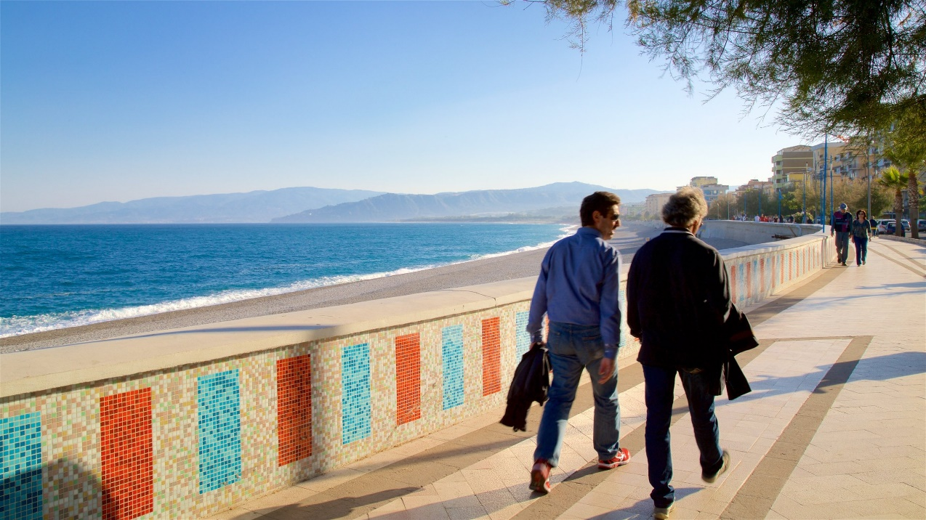

Tuesday March 7th:
-8:15 Departure by bus to visit Lake Ampollino;
- From 10:00 (approximately) to 10:30 visit Lake Ampollino;
https://it.wikipedia.org/wiki/Lago_Ampollino
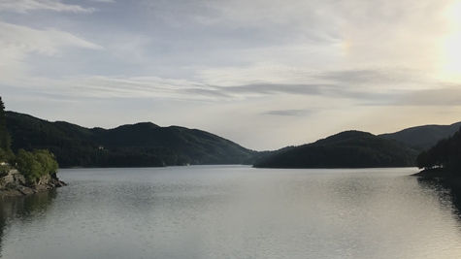
-10:45 Departure from Lake Passante;
-11:45 Visit Lake Passante;
https://it.wikipedia.org/wiki/Lago_Passante
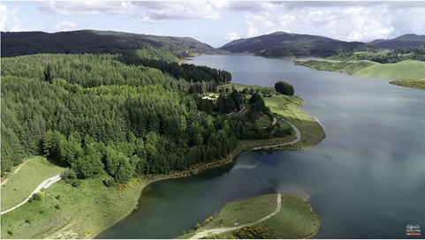
-12:30 Lunch (Packed lunch/ or lunch at the Farmhouse "Lago del Passante", menu 25 euro);
-After lunch (15:00/15:30) a walk in Villaggio Mancuso;
https://it.wikipedia.org/wiki/Villaggio_Mancuso
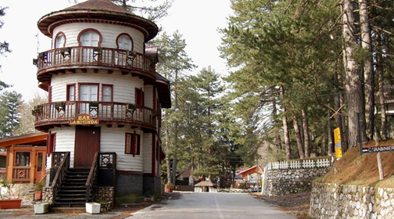
-17:00 Back to Catanzaro Lido.
Wednesday March 8th:
-8:15 School activities;
-9:15 Departure by bus for the visit to Carlopoli;
-10:00 Visit Acqua Leo- Carlopoli establishments;
https://www.bereacqua.org/acque/acquasi-fonte-leo/
https://www.corrieredellacalabria.it/2022/06/01/sostenibilita-ambientale-la-scelta-green-di-acqua-leo/
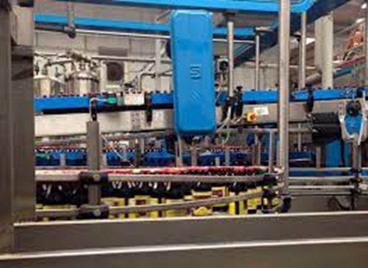
-12:30 Lunch (Packed lunch/ or lunch at the restaurant "Fossa del lupo", menu 20 euro);
14:00 Visit to the Corazzo Abbey
-16:00 Back to Catanzaro Lido.

Thursday March 9th:
-8:15 Departure for Le Castella;
https://it.wikipedia.org/wiki/Le_Castella_(Isola_di_Capo_Rizzuto)#:~:text=Punta%20delle%20Castella%2C%20pi%C3%B9%20nota,e%2040%20km%20da%20Catanzaro.
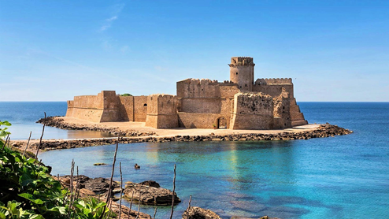
-9:15 Visit Aragonese Castle;
-10:15 Departure Crotone;
-11:00 Visit Carlo V Castle of Crotone;
https://it.wikipedia.org/wiki/Castello_di_Carlo_V_(Crotone)
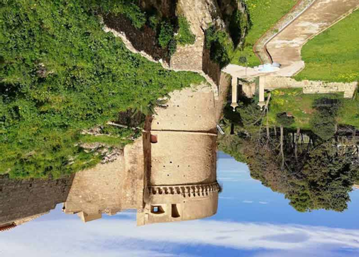
-12:30 Lunch (Packed lunch/ or lunch at the pub “Insolito” menu 15 euro);
-15:00 Visit the port and seafront of Crotone;
-17:00 Back to Catanzaro Lido.

Friday March 10th:
-From 8:15 to 10:15 Chemistry laboratory;
-10:30 Departure for Scolacium;
https://it.wikipedia.org/wiki/Scolacium
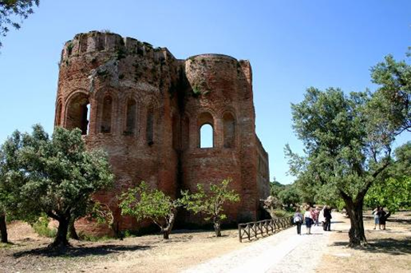
-12:30 Packed lunch;
-15:00 Departure for Biodiversity Park .
https://it.wikipedia.org/wiki/Parco_della_biodiversit%C3%A0_mediterranea
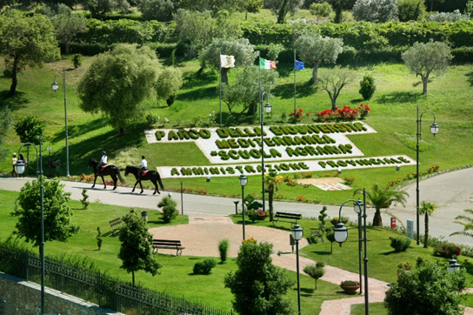
-17:00 Back to Catanzaro Lido.
Saturday March 11th :
-8:15 Review of the experience and goodbyes:
-13:15 Return home.

