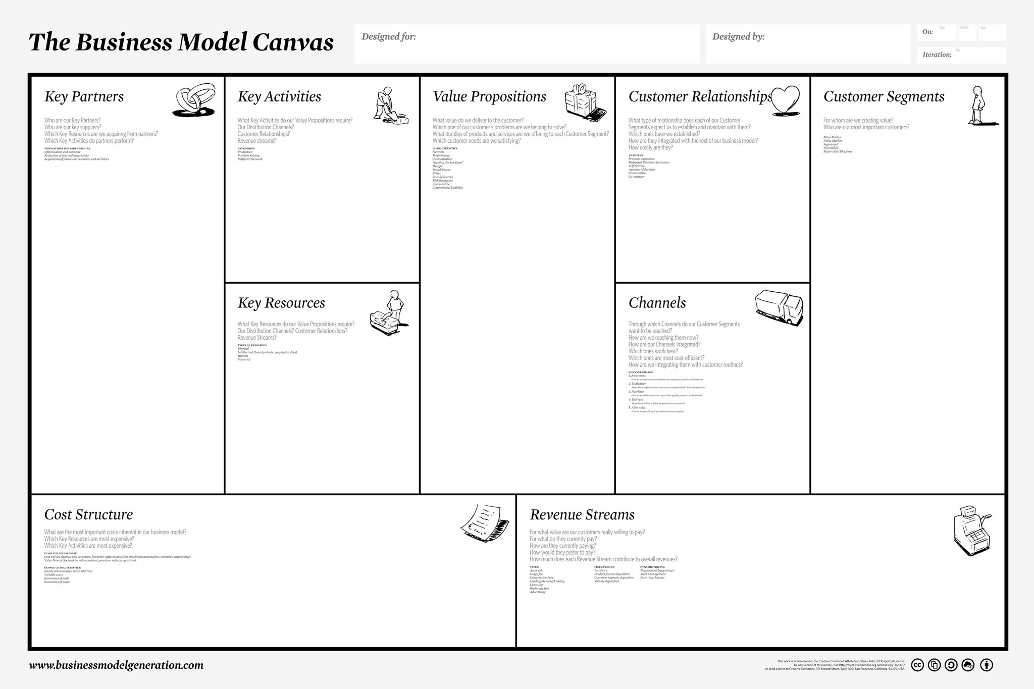
The partners will help us get more visibility and help us with the real product.
smaller customers, on the other hand, have the option of paying in 5 ways: credit card, prepaid card, paypal, bank transfer or cash on delivery.
Large companies, after delivery of the goods, pay a bank transfer or pay cash on delivery
We offer a product that is economical and beneficial to the customer, the environment and us as a company.
The most important costs included in the project are those for the construction of the finished product and the payment to the association we work with. On the other hand, the most expensive activity is the construction of the greenhouse.
We are creating this greenhouse for those who would like to grow something for themselves as a hobby or even professionally, starting from simple tomatoes to a daisy, all in a green way.
We are targeting companies that use pots and pollutants for their crops.
Instagram is the most efficient way to convey our voice to young people, but for those who do not have social media, flyers work very well
We reach our customers through social sponsorships, trade fairs, stands in their countries and the creation of flyers.
A relationship of respect for each other both because of the trust the customer gives us by buying our material, and because of the trust we give to his willingness to change
We are fulfilling our customers' desire to revolutionise the world of recycling and consumption.
We want to involve the customer in the new world of recycling and green, providing him with a product that does not pollute and can help him cultivate a new hobby
We offer a gardening set for our customers, consisting of different-sized pots, a rake and trowel for tilling the soil, and a small watering can. For larger companies, we offer genuine recycled greenhouses.
We want to make the customer realise how important it can be for the world to buy these products because, recycling has to come first these days.
our keyword is cultivation, our products will arrive to companies and customers by courier and will be perfectly packaged in recycled bubble wrap or newspapers and magazines so as not to pollute.
We would like to collaborate with PLASTI-LAB, which will supply us with plastic and PLASTIC FREE.
The partners will help us get more visibility and help us with the real product.

