Narrative report
Erasmus+ KA2
“Un homme sain dans un environnement sain”
Barreiro, Portugal
9th May – 14th May 2018
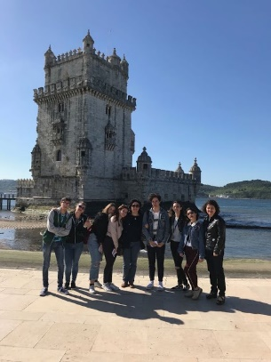
Written by: Natalia Wiśniowska, 3E “IIS Fermi” Italy.

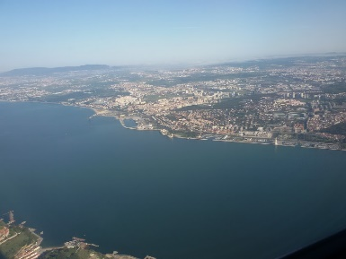
Thanks to the “Erasmus+ KA2” project, I have had the opportunity to visit Portugal (only nine students could participate, and I was the lucky one), with my French teacher, Caterina Mazzuca, my school’s Headmistress, Teresa Agosto and the other partners from this project (Poles and Rumanians).
Day 1: We left Italy in the morning of the 7th May. Initially I was stressed and anxious, because it was to be my first time on a plane, but then it passed.
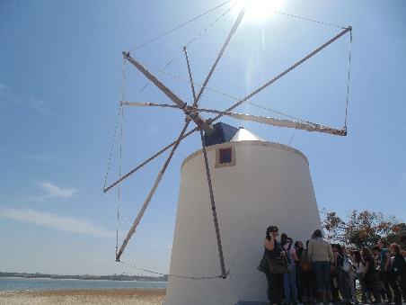
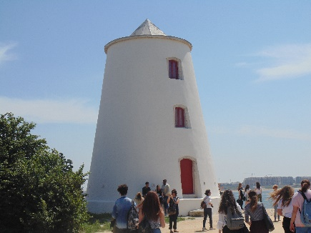
We arrived in Lisbon at 1pm, then we took a bus to reach the Portuguese school, situated in Barreiro. There the other partners welcomed us, and we had also a little buffet composed of typical Portuguese snacks. I really liked it! In the afternoon, we went to the Town hallin Barreiro, where we met the mayor, who told us about the town’s history. Later we visited the nearby windmill of Alburrica, learning aboutits past.

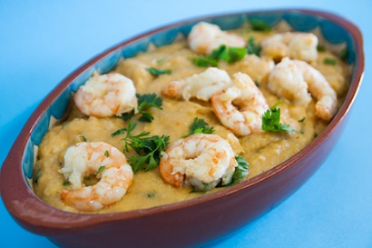
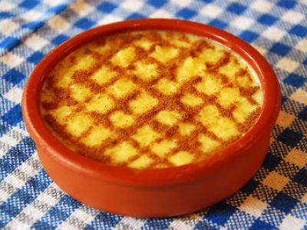
In the evening I met my correspondent’s family, who were very friendly and welcoming. For dinner, we had a Portuguese dish called “Açorda de Camarão”, composed of thinly sliced bread with garlic, finely chopped coriander, olive oil, vinegar, water, salt, poached eggs and shrimps, which was delicious, followed by a typical dessert called “Arroz doce”, which is a pudding made with rice, milk, egg, sugar and cinnamon.

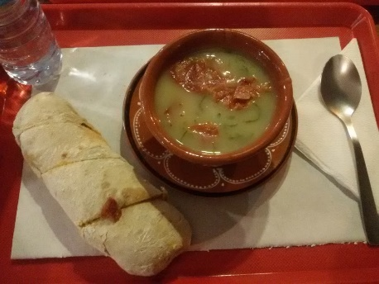
Day 2: On the 8th May we spent the whole day at school: we started by doing group projects about our ‘perfect place to live on Earth’. We had to prepare a Power point presentation (in French or in English) and then, one member of each group presented it. I was in a group with two Portuguese girlsand one Polish girl. Our keyword was “school”, so we talked about our ideas and we prepared our presentation. At first, I didn’t really enjoy it because I had to communicate with others, and I don’t usually do that because I’m shy, but I had discovered some new friends and in the end I really liked it. After that, we went to the gym to participate in some sports activities. To be honest, I didn’t enjoy that because I’m not used to playingany sport, so it was tiring for me. In the afternoon we had to give our presentations, and I presented ours (although I didn’t want to, because I didn’t feel courageous, but nobody else wanted to do it so I somehow found the courage).After that, we had a meeting with Joao Yuan, a professor from the University of Lisbon, who spoke to us about global warming.As a result of this meeting, I realized that our world is really in danger and there are some solutions, but everything depends on us, if we still want to save our planet. After leaving school we went to a wonderful, big park torelax a little. Then I returned‘home’ and for dinner we had a Portuguese soup called “Caldo verde”, made with potatoes, collard greens, sliced chouriço or linguiça (smoked Portuguese sausage) and olive oil. I really enjoyed it!
Day 3:We went to the Machada forest: first of all, we saw a presentation on some plants and animals thatare in danger of becoming extinct. Then we participated in an unusual activity: using our gloves and a pocketknife, we removed the cortex from some trees. It was very funny, seriously! In the afternoon we stayed at school, taking part in an activity related to recycling. In fact, we made a paper wallet. Then, there was a presentation about Expo, and at the end of the day we went to a small auditorium where we met the school director, who gave us a certificate of participation.
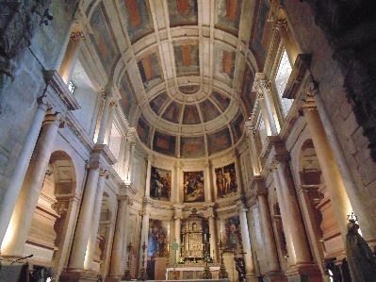
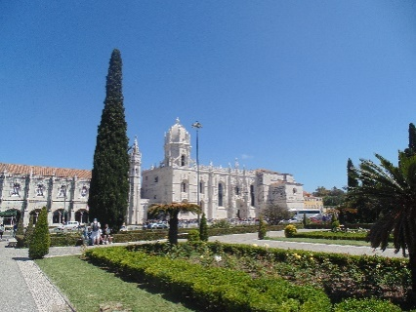
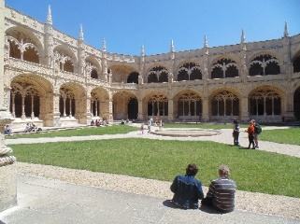
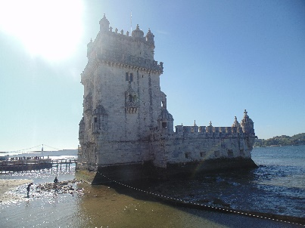
Day 4: On the 10th May, we went to Lisbon to visit some monuments. First, we visited the famous Belem Tower (which isone of UNESCO’s listed monuments), built as a fortress in 1515 in the Manueline style, to guard the entrance to Lisbon’s harbour. After this, we went to the wonderful Jeronimos Monastery,also built in the Manueline style, by King Manuel Iin 1502. It’s also known as the symbol of Portugal’s power and wealth during the Age of Discovery. In addition, inside we can find Vasco de Gama’s tomb.
Belem Tower

Jeronimos Monastery
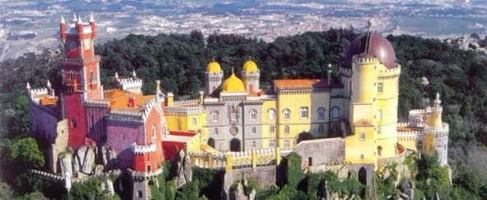
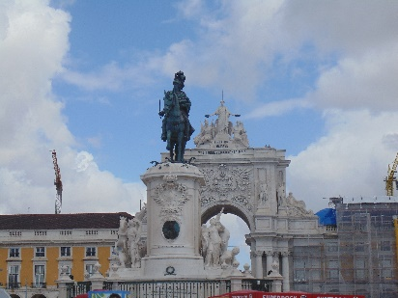
Day 5: We went to Sintra to visit the Pena National Palace, which is one of the most beautiful monuments I have ever seen. It was the first Romantic palace in Europe, and it’s a protected national monument, both a UNESCO World Heritage site and one of the official Seven Wonders of Portugal.In the afternoon, we went to the “Tapada de Mafra”, the oldest ecological reserve in Portugal: first, we participated in an Apiculture Atelier, where a beekeeper talked to us about bees (there are about 2000 species!), how they make honey, and he showed us some different types. Then, wehad a Train Tour,during which we saw some animals such as wild boars, antelopes and deer. At the end of the visit, we attended a Bird of Prey Performance, where we saw an owl and an eagle flying side to side.
Day 6:We went to Lisbon by boat and we visited the downtown area. Then we spent the rest of our time in the city shopping. It was a good day, I enjoyed it.

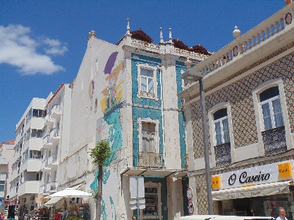
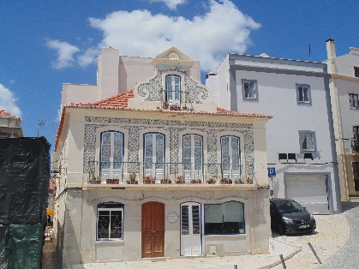
Day 7: On the 13th May I spent the whole day with my correspondent and her uncles. First, we went to Sesimbra, a small town known as the “townof fishermen”. It’s 38km away from Lisbon. I saw a lot of beautiful buildings and graffiti, while I was walking around.
Placa do Comercio

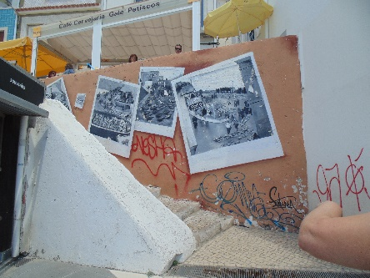
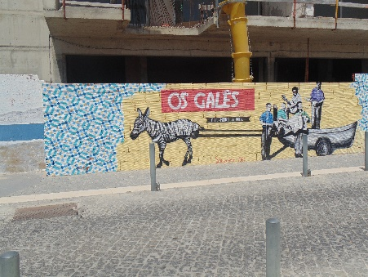

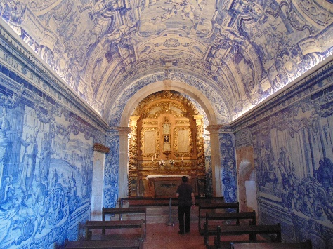
I also visited the Santiago fortress and the castle of Saint Philip (situated in Setubal). For lunch we had a typical local dish, sardines.
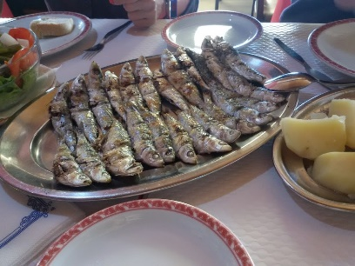
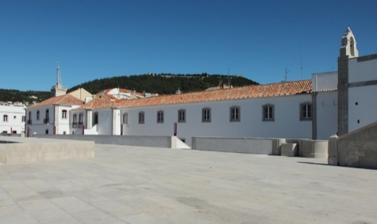
inside the Saint Philip's castle
Santiago's fortress

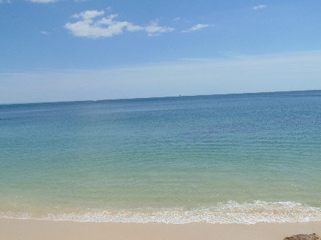
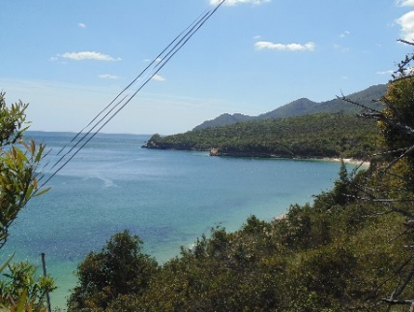
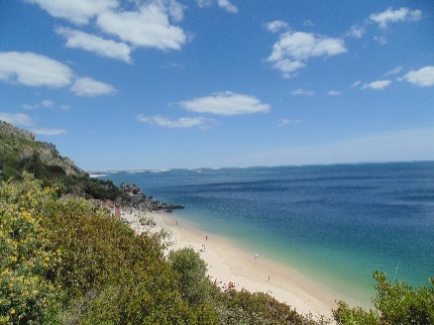
The most beautiful landscape that I saw was, of course, the coaston the Atlantic Ocean …
Day 8: We left Portugal at 10:55am. Before leaving, it was hard to say goodbye to our new friends, but we all agreed that we will meet again one day.

Conclusion
This was the best experience that I’ve ever had in my life. I discovered new places, a new culture, new traditions and new people. In the beginning I was very insecure and anxious because, for the first time, I was in a foreign country without my parents or friends, and for a shy person (like me) it’s very hard to make new friends or to join in a conversation. In this case, I challenged myself, and I won. I became braver and I made new friends (from other countries too).
History: I noticed that the Portuguese people value their historygreatly, for example,how they suffered during the dictatorship. In fact, my correspondent’s mum told me that the most important day for the Portuguese people is 25th April, the day when the Carnation Revolution happened and the dictatorship was abolished. In addition, every single year, in Portugal there are two songs played on the radio, because they were heard before and after the revolution: “E Depois do Adeus “and “Grândola vila morena”.
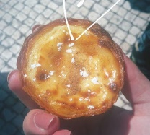
People: the majority of the people are very kind, welcoming (and pretty!). For example when I was there, I felt like I was at home, and I still miss “my” Portuguese family.
I noticed too that, in general, they (the Portuguese) don’t like being mistaken for Brazilians or Spanish. They insist that they are completely different from them.
Cuisine: To be honest, Portuguese food is delicious! I had the chance to taste a lot of typical meals and sweets. My favorite was Pastel de Nata! Furthermore, they use a lot of eggs, cinnamon, fish, garlic, bread and coriander. Marvellous!
Arts: I’m a lover of Art, and when I saw those wonderful monuments, graffiti and buildings, I fell in love with them. I didn’t want to leave those places.
In conclusion, I’d like to say that this experience has changed me in a positive way, and it has certainly improved my English too. If I havethe chance to go back there, I will take the first plane and relive every moment.

