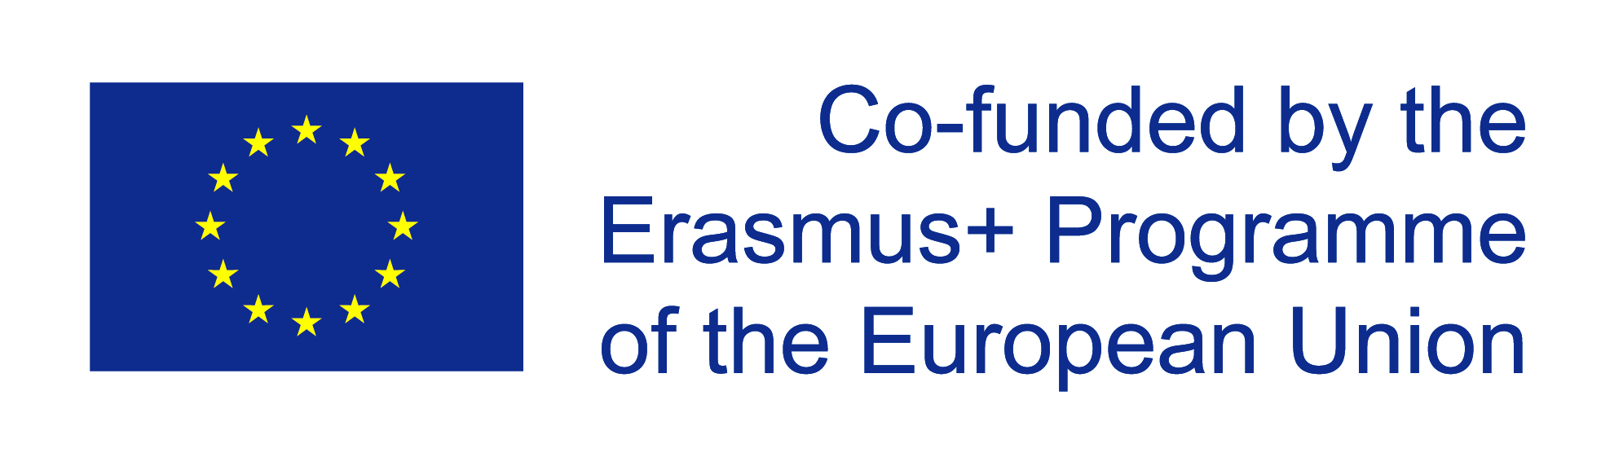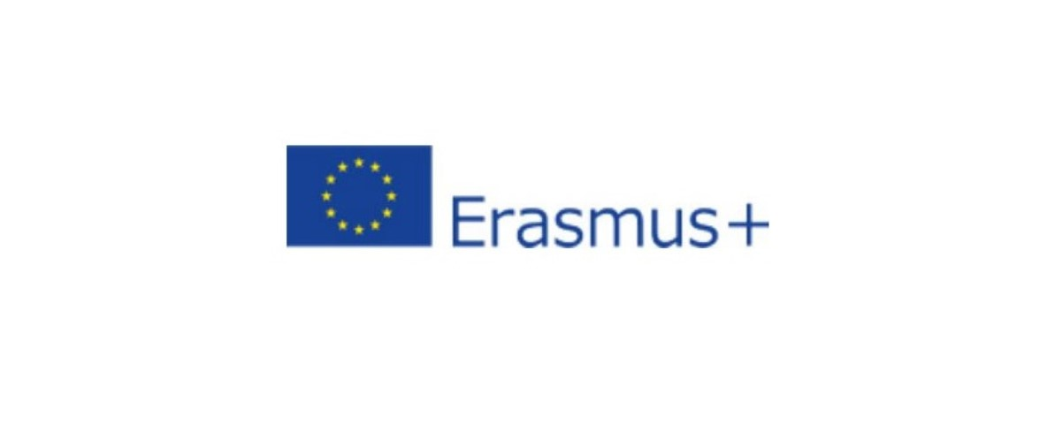
ERASMUS+
FINAL REPORT
SHORT-TERM MOBILITY
OLIVEIRA DO BAIRRO, PORTUGAL
11-24 OCTOBER 2023

Thanks to Erasmus we have had an experience that we won’t easily forget: an individual mobility in Portugal. We spent fifteen days in October studying in Agrupamento de Escolas de Oliveira do Bairro, in Aveiro. We had the opportunity of learning in an alternative way, promoting the values of inclusion and equality, the knowledge of common heritage and European diversity, at the same time improving our English skills. As well as the cultural and learning experience, we established good relationships with the host families and maintained those with the students that we hosted last year.
During our stay, the families took us to visit the most important and well-known places near the city. We lived with an actual Portuguese family sharing every moment and activity with them.
Our days were spent mostly at school, where we experienced the big differences between the Italian and Portuguese school system. We had the opportunity to experiment a school system really different from ours: other than having different studies paths, lessons start at 8:30 am and finish at 5 pm, which may seem really tiring, but thanks to the pauses after every hour and the right distribution of the classes during the day, it becomes more enjoyable, all of this gets paid with the free saturday. The school also has some recreational rooms, such as the library or the students room, in which kids can spend their free time in the way they want. In the entrance of the building, there’s a place where the students scan their cards, that notes the presences and school isn't really strict about exits, in fact students can exit school independently to go to the school gym or the neighboring areas. We were all accepted in the best way by our families that treated us as daughters. We shared with them this fantastic experience and we spent together moments of their everyday life. Despite the cultural differences, the families and the people in general are really similar to us, hospitable and welcoming. They let us know their culture and since the beginning were eager to know ours. With this experience we made new friendships and we became part of a family that, despite the distance, will always have a special place in our heart.
This experience has strengthened our ability to adapt, increased our autonomy and enhanced the curiosity towards new cultures, so different yet so similar. We are happy to have had the chance to live this wonderful experience and we hope that we can repeat it in the future, to increase our cultural heritage. In conclusion we wanted to say thanks to our school, our teachers, and the headmistress Mrs Agosto T., who gives us students the chance to live this kind of experience and to spread our horizons.

Aversa Ilaria, Campeggio Roberta, Nocita Nadia, Zaccone Jennifer

