Business Idea
Re-Generation

IO3 - OUTSIDE Green Business Collection

A: Brescia Luigia- Perri Lucia- Gullà Luana- Mellace Serena- Leone Alessia- Valenti Ilaria- Giglio Emanuele- Riccelli Giulia- Marturano Elisa- Laugelli Sara- Darhourhi Amine- Silipo Swami

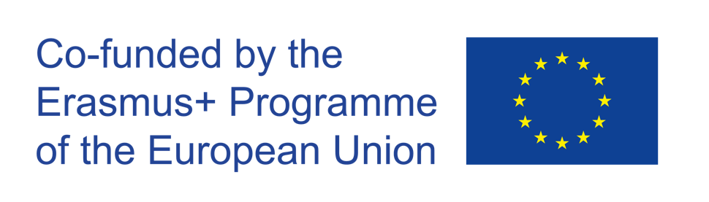

The European Commission's support for the production of this publication does not constitute an endorsement of the contents, which reflect the views only of the authors, and the Commission cannot be held responsible for any use which may be made of the information contained therein.
Project: “OUTSIDE- Open commUniTies for SustaInable DevelopmEnt” Nr. 2020-1-IT02-KA201-079803

Introduction

OUTSIDE is a European project funded by the Erasmus+ Programme (Key Action 2 –Cooperation for Innovation and Exchange of Good Practices). The duration of the project is of 30 months, from October 1st 2020to March 31st 2023. OUTSIDE is implemented by 5 European Countries (Italy, Belgium, Croatia, Lithuania, UK). The Partnership is made up of 5 Schools and 4 Organizations active in the field of sustainable development & entrepreneurship. OUTSIDE has the general objective to promote the acquisition of key and innovative competences among students, through the creation of entrepreneurial projects in the field of sustainability.

In each piloting country, partners will be responsible for the organization of training groups of students aged 11-17 that will deliver at least 3 green projects per country (Intellectual Output 3).

Title of the business idea: “re- generation"

Description  Link to the OUTSIDE Toolkit: Module 4 Session 4: Development of a green business idea | Re-Generation is an association that deals with the creation of high quality works. The goal is to use plastic for the necessary tools and for the realization of the project.  This group consists of 12 people and includes as many customers as possible  Our creation wants to involve customers who do not have the opportunity to take part because they live in an unsuitable place or people who want to immerse themselves in a new world
The local environmental challenge  Link to the OUTSIDE Toolkit: Module 4 Session 3: Mapping local environmental challenges | The objective of the project we have created is to combat various environmental problems that are of concern all over the world, but especially in the area where we all live. Our protection of the environment focuses on fundamental territorial problems: pollution due to plastic, which is thrown away without recycling, the exploitation of territories, the waste of different materials, food production by industries that pour toxic substances into the environment, and the waste of raw materials.
Skills  Link to the OUTSIDE Toolkit: Module 7  Session 2: how to create and run sustainable team  Session 4: how to boost internal and external communication skills of the team | Our team has numerous skills, first of all knowing how to use technology, essential for the promotion of the final product. And we also have the critical conscience that leads us to create a project to improve the world. However, we would need more funds and more visibility.
Resources  Link to the OUTSIDE Toolkit: Module 3 Session 2: Mapping and connecting with the external community | Internal resources are the People who belong to our social environment and whom we feel can provide us with help, support or protection. This list includes wellness professionals, support groups, work colleagues, even a caring neighbour can become a resource.  The external resource given to us by society and the world is first and foremost plastic, which will be the basis of our project. but a company that supports us and helps us develop our idea is also indispensable.
Financial planning
Link to the OUTSIDE Toolkit: Module 7
Session 1: getting started with project management
Session 3: how to manage a green project
Green Business Model Canvas
Link to the OUTSIDE Toolkit: Module 7
Session 3: Developing a green business model canvas
Possible impact | The possible impacts that this company can have are many: Reduction of the exaggerated use of plastic in our locality. More green environments will be employed, more jobs and more youth involvement.
Marketing and product pitch  Link to the OUTSIDE Toolkit: Module 8  Session 2: Utilizing the digital skills and social media to boost business ideas  Session 3: Making Social Media strategy to boost green business ideas | We would like to sponsor our project in various forms and especially with a poster and a video because we think they can reach the public faster and are more understandable.
Space for the pictures and videos | 