Business Idea
B&coB

IO3 - OUTSIDE Green Business Collection

Samuele Elia, Enrico Vitale, Vincenzo Megna, Domenico Antonio Colao, Erika Putrone, Francesca Lisi, Giulia Giglio, Giorgia Caccavaro, Monia Fodaro, Luna Santo, Sara Santo
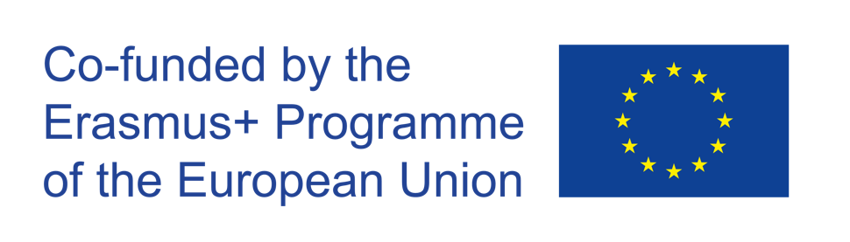

The European Commission's support for the production of this publication does not constitute an endorsement of the contents, which reflect the views only of the authors, and the Commission cannot be held responsible for any use which may be made of the information contained therein.
Project: “OUTSIDE- Open commUniTies for SustaInable DevelopmEnt” Nr. 2020-1-IT02-KA201-079803

Introduction

OUTSIDE is a European project funded by the Erasmus+ Programme (Key Action 2 –Cooperation for Innovation and Exchange of Good Practices). The duration of the project is of 30 months, from October 1st 2020to March 31st 2023. OUTSIDE is implemented by 5 European Countries (Italy, Belgium, Croatia, Lithuania, UK). The Partnership is made up of 5 Schools and 4 Organizations active in the field of sustainable development & entrepreneurship. OUTSIDE has the general objective to promote the acquisition of key and innovative competences among students, through the creation of entrepreneurial projects in the field of sustainability.

In each piloting country, partners will be responsible for the organization of training groups of students aged 11-17 that will deliver at least 3 green projects per country (Intellectual Output 3).

B&coB: “Samuele Elia, Enrico Vitale, Vincenzo Megna, Domenico Antonio Colao, Erika Putrone, Francesca Lisi, Giulia Giglio, Giorgia Caccavaro, Monia Fodaro, Luna Santo, Sara Santo"

Description  Link to the OUTSIDE Toolkit: Module 4 Session 4: Development of a green business idea | 1. The main people behind this business plan are the entrepreneurs who will have to finance our idea and make it a reality that can be within everyone's reach. The target audience, on the other hand, are customers with a medium-high culture who understand the value of eco-sustainable interventions and are willing to pay more for an environmentally friendly holiday. It is for this reason that the main marketing actions will aim to reach the customer with a high cultural profile, by publishing advertisements in national and international newspapers, disseminating articles in magazines specialized in exclusive travel.  2. The business idea stems from the desire to offer, unlike its competitors, a B&B service in areas that are not strictly central to the main tourist cities, but where the historic center can be reached on foot or at most by bike via the cycle path. This guarantees the possibility of experiencing the holiday in a less chaotic condition. What we offer? Structures in residential areas adjacent to historic centers, Plants, furnishings, completely ECO, BIO nutrition, Know How represented by staff who fluently speak at least two foreign languages, who have a school background and at least 2 years of experience in the management of accommodation facilities . He must also have successfully attended a course on BIO and ECO products.  3. The project is very expensive both from the point of view of the resources that are made available by the entrepreneurs but also of the time it takes to be able to give this type of service to the men and women who will later want to use it. It is a very important project. We would like to reach a very high level within 7-8 years for the standards that we have today in Bed & Breakfasts, a sector that has grown rapidly in recent years. The business must be started as soon as possible because it would be very important to enter this sector without others coming up with this very innovative idea.  4. For a number of different reasons including these: The pricing policy will be aimed at customers willing to pay a maximum price of 15% higher than the average. Each BIO B&B, precisely for the consumer segment it is aimed at, will have at least one meeting room and a well-stocked library. In each ECO B&B it will be possible to buy organic products from the area. It will be possible to make excursions to organic farms in the area. Finally, the business idea includes the possibility of building your own holiday with packages that allow you to stay in structures with the same characteristics as the European capitals where you want to stop.  5. The seat from which everything starts is certainly a small town also in our region in order to then be able to extend gradually, on different places and on different places even in the same place as it could be for important cities such as Milan or Rome, and then increasing the capital at our disposal also thanks to the social channels, also to reach Europe via the media and then to the world level to bring a service that we believe will be very convenient for many people.
The local environmental challenge  Link to the OUTSIDE Toolkit: Module 4 Session 3: Mapping local environmental challenges | The environmental challenges we want to address there is certainly that of plastic, now about 8 million tons of plastic waste ends up from coastal nations into the oceans. It is equivalent to throwing five bags of garbage every 30 centimeters of coast all over the world. Most of the plastic that is in the ocean comes from the mainland. Or it is carried by the larger rivers, which act as a conveyor belt picking up garbage on garbage as they go downstream. Once in the sea, much of the plastic waste remains in coastal waters. But by the time they are caught in ocean currents, they can end up all over the world. But also the so-called "polluting" foods, but we could ask ourselves how does food pollute? Simple, eating out of season products from other countries after endless crossings overseas. All to the detriment of the environment, increasing the greenhouse effect. Not to mention the indifference towards our own products, victims ignored with the aggravating circumstance of excessive expenses for the purchase of products that are absolutely not Made in Italy. By purchasing out of season products we contribute to environmental pollution and this is now clear. Among the most polluting foods imported into Italy are cherries from Chile. To make them reach our tables, making our taste buds explode with pleasure, they travel the beauty of 11,968 km of distance. Traveling on such a route means consuming 6.9 kg of oil. Not only that: to aggravate everything there will be an emission equal to 21.6 kg of CO2 (carbon dioxide). This is just one example of how much more polluting food can be than we expect.
Skills  Link to the OUTSIDE Toolkit: Module 7  Session 2: how to create and run sustainable team  Session 4: how to boost internal and external communication skills of the team | The team skills we certainly have that of doing everything together as if we were a family and this is precisely what must distinguish us from other B&B chains. We have a good ability to communicate with other people and welcome them in our company but also a lot of dedication which is very important to be able to open a project as wide-ranging as ours. Among the skills we have at our disposal, in addition to welcoming them and communicating with people, we are able to manage the booking of the rooms at our disposal thanks to our dedicated website, but we also know how to manage the check-in and check-out procedures. Instead, among the skills we need is the fact of carrying out the commercial management of the Bed & Breakfast precisely because it is the first time for us, so we should ask for the help of an expert who can point us in the right direction. But also having to carry out first aid, which is very important for a company like ours, our staff must have this license, because it is very important that our customers also feel safe when it comes to safety.
Resources  Link to the OUTSIDE Toolkit: Module 3 Session 2: Mapping and connecting with the external community | Among the internal resources we have there is certainly our communicative characteristic with others that we can fully exploit in this new field of work. Among our members, we can use our work experience elsewhere to do the best in this sector, which is why it is very important for us to have a team that we really get along with. Surely we can also count on our physical characteristics that can help in the creation of the different places that can then be used for our chain. Clearly, in addition to the internal resources we can count on, we also have external resources on which we can really make a difference, certainly we can count on a large group of friends and acquaintances who can help us in the realization of our project, the sponsors who will be a part fundamental to ensure that the future of the B&B that we would like to bring to is known to as many people as possible. Finally, we can count on training courses and on the skills that our employees must acquire, through free courses so as to be able to define cutting-edge skills.
Financial planning  Link to the OUTSIDE Toolkit: Module 7  Session 1: getting started with project management  Session 3: how to manage a green project | Our financial plan is based on the provision of our services where savings will not be aimed at because it would not be strategic. The main costs that will have to be faced are: rental of the structure, Eco renovation of the same, purchases of eco-sustainable furnishings and accessories, personnel costs, fees of architects, engineers, lawyers, accountants, fees to non-mass communication companies, costs for staff training. With regard to the latter costs, it should be noted that it would be possible to make savings by aggregating the employees of the B&B in the various cities in the same training session. The value of our company will come from the sale of hotel services which is the core of the business. Our services will be sold to medium - high culture customers with reasonable economic possibilities according to the channels indicated above. Payment will be made in a lump sum up to the sum of 3,000 euros. Above, it will be possible to pay in installments according to a plan that takes into account the amount. Accessory services (purchase of BIO products, bike and electric car rental, excursions ...) can be paid for either by debit card or with the main international credit cards.
Green Business Model Canvas  Link to the OUTSIDE Toolkit: Module 7  Session 3: Developing a green business model canvas | 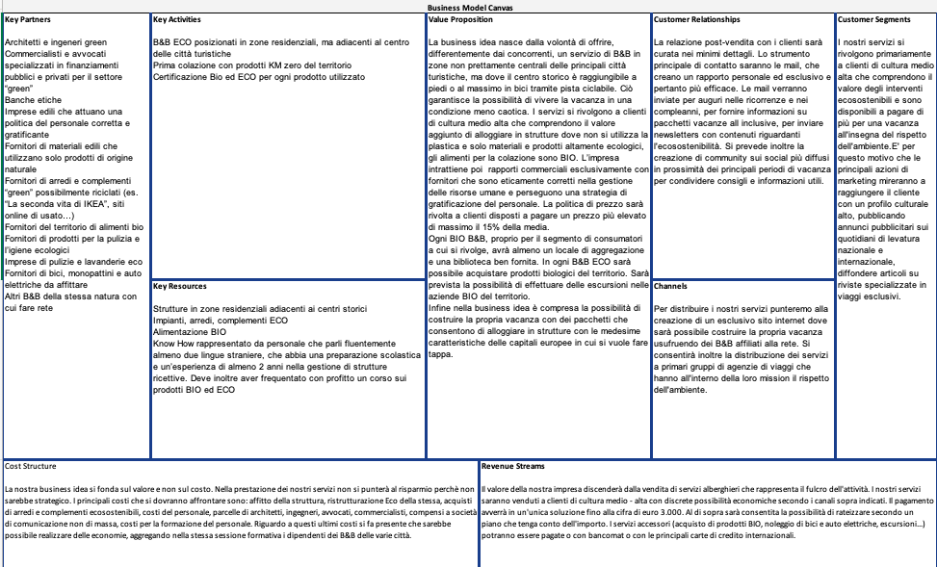
Possible impact | The impact on our local community could be very interesting, but we think that on a national scale the impact could be even better, in fact on our local community the impact we will give will be mainly due to the recycled furniture compared to the BIO production which instead it will be more important on a national scale given the high production in our region of food that is then imported in various places in Italy and around the world.
Marketing and product pitch  Link to the OUTSIDE Toolkit: Module 8  Session 2: Utilizing the digital skills and social media to boost business ideas  Session 3: Making Social Media strategy to boost green business ideas | To distribute our services we will aim to create an exclusive website where it will be possible to build your own holiday by taking advantage of the B&B affiliated to the network. It will also allow the distribution of services to primary groups of travel agencies that have respect for the environment as part of their mission. Surely to promote our idea we need sponsors who are indispensable for the increase in popularity and to make us known by as many people as possible, the different channels will also be very important, we would like to promote it also through an Instagram page so that people can get to know us. through advertisements. The format to promote our idea will certainly be the social one and therefore we will use technology to reach the different social classes of our society.
Space for the pictures and videos | 